DG3NLP – Natural Language Processing
Lauryn Manu, 200075589

- Introduction
Classifying text such as tweets based on emotions expressed in the text is important, because users need to be able to access tweets relating to what has been searched. This report will cover my research and project on Emotion Classification of Tweets. Classifying Social media platform X (formerly Twitter) is a popular microblogging platform. It allows users to share ideas and discuss different topics based on opinions and emotions. Understanding emotional triggers from tweets is essential in gaining insight on why tweeters communicate the way they do (Li and Xu, 2014). It is important to understand how context in tweets and other texts give a strong indication as to why someone feels certain emotions. If emotion classification isn’t prioritised, when users emotionally search online relatable text, there is a potential risk that presented unrelated text would not only be unhelpful but could also be harmful. Text classification allows texts such as tweets to be divided into categories based on topic and emotion.

- Background Research
Very effective methods such as Deep Learning are currently used today for research and studies. There are multiple kinds of Deep Learning models with different purposes. For example, Long Short-Term Memory (LSTM) is a Recurrent Neural Network model developed in 1997. LSTM and Bi-Directional LSTM models are a couple methods used to analyse emotions felt in tweets from the public health emergency outbreak of Monkeypox in 2022 (Olusegun et al., 2023). This shows why tweet emotion classification is essential, because collecting data on psychological effects the outbreak had on people can help us understand what measures are needed to be taken to assist people in easing any anxious emotions. Another method currently used is Linear Discriminant Analysis, which is a classifier that uses Bayes’ rule. Bayes’ rule is a probability formula that updates the chances of a proposition as the classifier receives more data. Being used to classify political speeches into emotions and context is important research, because what is being said in the world of politics holds the most influence on different communities. It can help us notice tension between parties and be used as early signs for potential war (Efat et al., 2023).

- Requirements
The goal of this project is to train a supervised machine learning classifier called Support Vector Machine (SVM), with the ability to automatically classify tweets into one of six categories based on the emotions anger, fear, joy, love, sadness and surprise. This project also gives me the opportunity to evaluate the effectiveness of using a machine learning model like SVM for short and informal text data.
To achieve my goals, a provided dataset that contains 16,001 tweets in the English language is used. The tweets are individually labelled with one of the six emotion categories symbolised as numerical values ranging from 0 to 5.
To evaluate the model, various metrics are implemented; Accuracy, Precision, Recall, and F1-Score. A confusion matrix has been created to visualise the performance of the SVM classification model, showing the counts of true positive, true negatives, false positives and false negatives. The high counts for the true positive/negative data indicate more correct predictions. The high counts for the false positive/negative data imply incorrect predictions. Calculating accuracy is not enough when gathering evaluation metrics, because it only covers the overall performance of the model. However, the other metrics cover the model data in depth.
Various preprocessing techniques are needed for this project. For example, lowercasing, which is a method of data cleaning, is needed to guarantee consistency within texts. A lexical analysis method such as tokenisation is needed to break raw text into understandable segments. Removing stop words is important to reduce noise by eliminating unnecessary words like “is”, “a”, “like” and more, therefore the model can focus on significant words helpful with classifying emotions in the tweets. Other techniques such as vectorisation using TF-IDF, emoji-handling, and hashtag cleaning could be used for emotion classification of tweets as well.

- Design and Implementation
Whilst creating the Support Vector Machine, multiple preprocessing techniques were used. Term Frequency-Inverse Document Frequency (TF-IDF) was included in the code as a form of feature extraction. It is an extension of the Bag-of-Words representation, used to count the word frequency and adjusts the importance of words depending on how common or rare they occur across the dataset. The TF-IDF vectoriser automatically includes lowercasing and tokenisation, as these techniques are built into the Scikit-learn library. Lowercasing converts all text to lowercase letters, reducing the vocabulary the model needs to learn. Tokenisation is then applied to split the text into tokens.

Figure 1 – TF-IDF Vectoriser

As seen in Figure 2, stop-word removal is used to filter out unnecessary words, which improves the model’s efficiency. Lastly, the vectorisation process consists of converting raw text data into numerical values, therefore the SVM classifier can understand and process the data.
Figure 2 – TF-IDF Vectoriser and Stop-words removal

The data was split into train and tests sets; 70 percent of the dataset was used to train the model, and 30 percent was used to test the model. The type of algorithm to train was selected as the Support Vector Classifier (SVM). The model was then able to have the training data “fit” into it, meaning that the data was learned by the model. Once the model was trained, predictions on the dataset before hyperparameters was displayed. Using a GridSearchCV, hyperparameter tuning was implemented with a linear kernel chosen. Linear kernel is quite effective for text classification, therefore making it suitable for this task. The GridSearchCV finds the best combination of the C, gamma, and kernel Hyperparameters for the model.

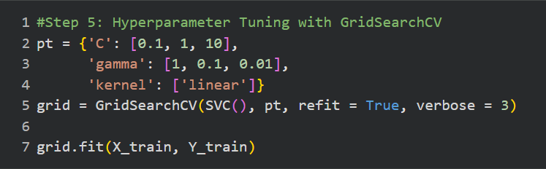
Figure 3 – Hyperparameter Tuning with GridSearchCV

The most reliable hyperparameter and ideal model is then identified. With this newfound information, two types of a confusion matrix were created to evaluate the model performance in depth. Innovative thinking is introduced during the evaluation stage by including a normalised confusion matrix as well as a confusion matrix without normalisation. With a visual comparison of both confusion matrices, we can see the difference between the raw prediction counts in the confusion matrix without normalisation and the percentage prediction counts in the normalised confusion matrix. However, the normalised confusion matrix presents an easier comparison on the model performance.

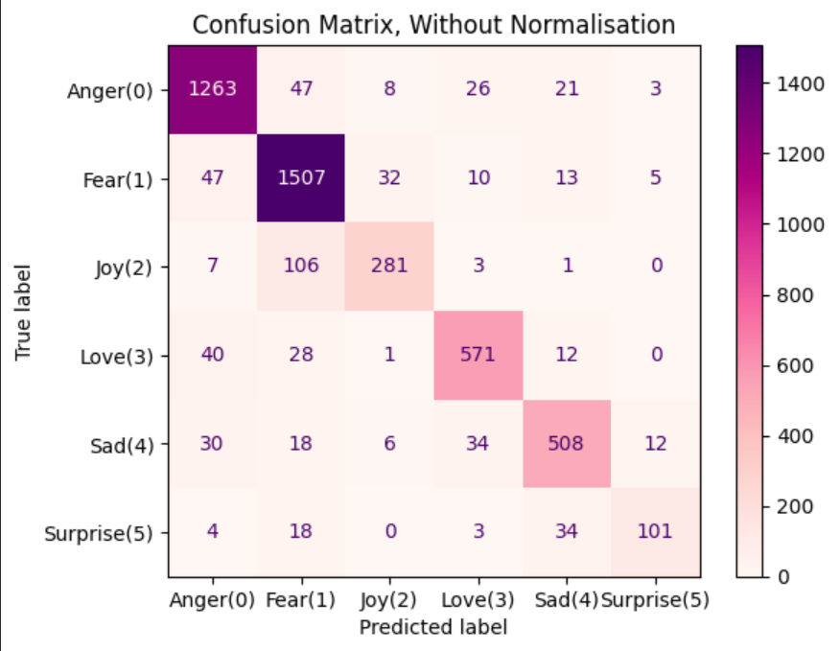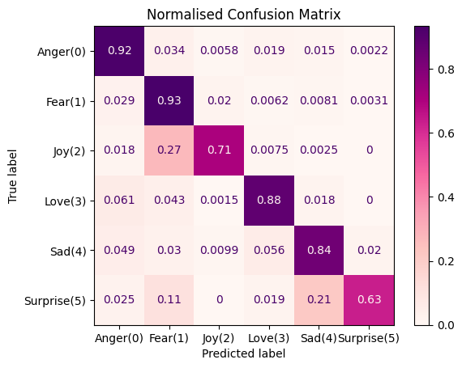
Figure 4 - Confusion matrix with and without Normalisation

- Evaluation and Conclusion
Overall, the model’s performance is simple and efficient. The preprocessing techniques used provide advantages to the model. For example, removing stop words from the tweets reduces the computational costs, and decreases the processing time. This helps to maximise the model’s performance. Lowercasing delivers consistency within the dataset, thus reducing the irregularity caused by the differences in casing. It also simplifies tokenisation process, preventing it from handling the case sensitivity. The accuracy output for the predictions without hyperparameters was 0.83, and for predictions with hyperparameters the output was 0.88. These comparisons show that the model’s performance is improved after hyperparameter tuning. Yet, the model is still not 100% accurate even after combining the hyperparameter tuning. From the data gathered by the normalised confusion matrix, the emotion with the highest count is Fear, reading 0.93, and Surprise has the lowest count, reading 0.63.
The code runs smoothly with no errors, and correctly does what it’s tasked to do. To increase the model’s accuracy, exploring other tokenisation methods the model used could have improved the model’s performance. There are three types of tokenisation: Word-based, Sub word-based and Character-based. By default, the TF-IDF vectoriser uses word-based tokenisation. Word-based tokenisation comes with challenges, such as ambiguity. As most of the tweets in the dataset are informal, there are words such as “I’m” often written as “im” in the text. This can confuse the tokeniser from understanding that the tweeter means “I am”.
What could also be improved is that logistic regression could have been included as a model to compare the performance against the SVM model. Logistic regression compares predictions with the truth when evaluating the model, and the data gathered could be compared with data collected from the SVM model.
  - References
- Introduction and Background Research
  - Li, W. and Xu, H. (2014) ‘Text-based emotion classification using emotion cause extraction’, Expert Systems with Applications, 41(4, Part 2), pp. 1742–1749. Available at: https://doi.org/10.1016/j.eswa.2013.08.073 (Accessed: 02/12/2025).

  - Olusegun, R., Oladunni, T., Audu, H., Houkpati, Y. and Bengesi, S. (2023) ‘Text mining and emotion classification on Monkeypox Twitter dataset: A deep learning–natural language processing (NLP) approach’, IEEE Access, 11, pp. 49882–49894. Available at: https://doi.org/10.1109/ACCESS.2023.3277868 (Accessed: 11/12/2025)

  - Efat, A.A., Atiq, A., Abeed, A.S., Momin, A. and Alam, M.G.R. (2023) ‘EMPOLITICON: NLP and ML based approach for context and emotion classification of political speeches from transcripts’, IEEE Access, 11, pp. 54808–54821. Available at: https://doi.org/10.1109/ACCESS.2023.3282162 (Accessed: 13/12/2025).

  - Use of AI
Artificial intelligence was used to create a study plan to guide me on what I should work on each day until the deadline and checked my grammar.

